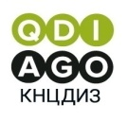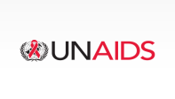

Press Announcement 01.12.25
December 1 – World AIDS Day
On December 1 at 11:00, a press conference dedicated to World AIDS Day and Kazakhstan’s participation in the global campaign under the motto “From Challenges to Solutions in the HIV Response” will be held at the UN Office in Almaty.
Speakers:
- Roza Kuanyshbekova, Director of the Kazakh Scientific Center of Dermatology and Infectious Diseases, Ministry of Health of the Republic of Kazakhstan
- Eleonora Gvozdeva, Director of the UNAIDS Office in Kazakhstan
- Nuraly Amanzholov, President of the Kazakhstan Union of People Living with HIV
During the press conference, the following issues will be addressed:
- the epidemiological situation in the country;
- Kazakhstan’s achievements in overcoming HIV;
- preventive work among the general population and key groups;
- collaboration with international organizations, NGOs, and the community.
Accreditation is mandatory.
Contact: Marina Maksimova +7 777 225 46 01

