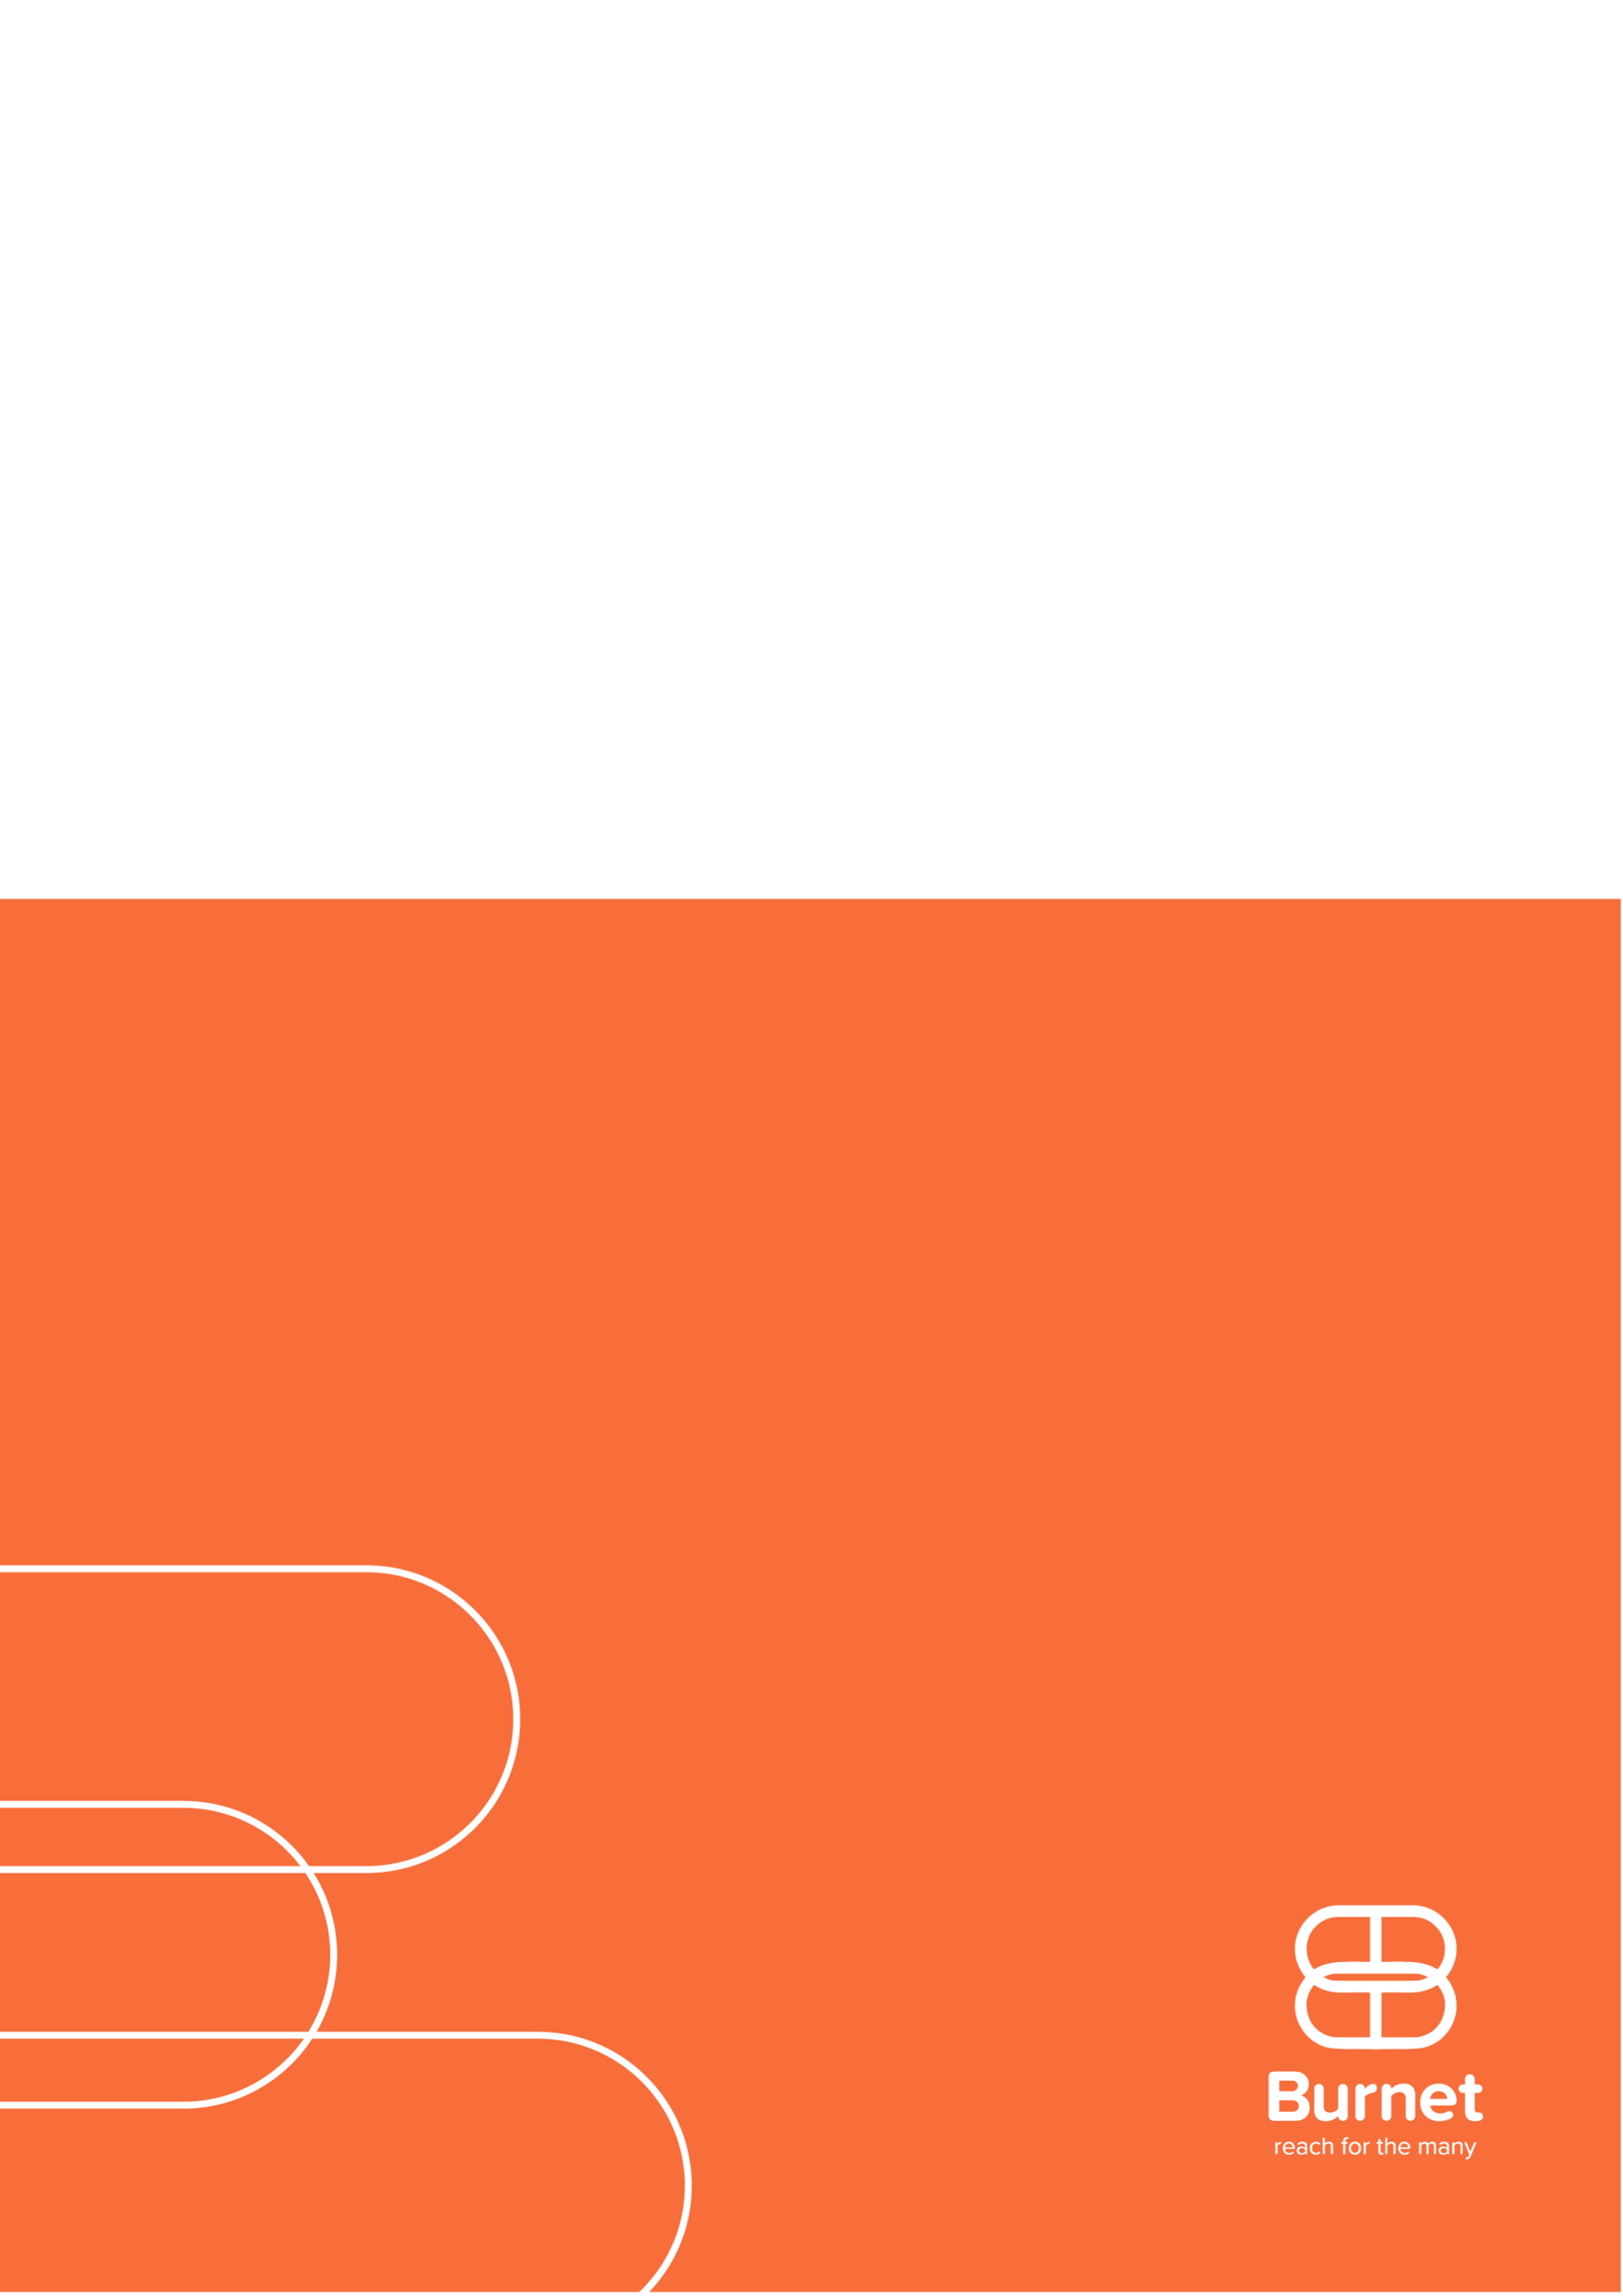
Optima HIV
Kazakhstan
Allocation of HIV Resources to maximise the impact of funding in selected Eastern European and Central Asian countries – 2025/26 analysis
April 2026

Executive summary
Global progress in reducing new HIV infections and HIV-related deaths has not been matched in Eastern Europe and Central Asia, and the region faces a growing HIV epidemic (1). To ensure that progress against the HIV epidemic can continue, it is vital to make cost-effective funding allocations decisions to maximize the impact of HIV programs. In late 2025-26, the Kazakh Scientific Center of Dermatology and Infection Diseases (KRCDIZ) the Global Fund, and the Burnet Institute conducted an allocative efficiency modelling analysis in Kazakhstan.

Key findings and recommendations

- In 2024 an estimated US$38.6 million was spent on targeted HIV interventions, with the majority of spending on HIV treatment and care (ART, 65%) followed by facility-based testing outside of key populations (20%).
- If funding for all key population-focused testing and prevention services was removed in 2026 and only treatment and facility-based testing services maintained–including fixed proportion on diagnosed people on ART–there could be an additional 4,276 (+50%) new HIV infections and 59 (+3%) HIV-related deaths relative to the status quo over 2060-2030.
- Based on Optima modelling, modelled ART coverage among diagnosed people living with HIV was 90% in 2024 (the latest reported year of treatment data) and this coverage was assumed to have been maintained in 2025. To continue to maintain this treatment coverage, annual treatment spending for ART and PMTCT would need to increase by US$6.7 million per annum (p.a.). Maintaining the “status quo” proportion of diagnosed people living with HIV on treatment will require additional future investment in HIV, further reductions in ART unit costs, or reallocation of resources from other HIV programs.
- Given the Government’s commitment in Kazakhstan to continue to provide HIV treatment to all those in need, the budget optimisation with additional resources to meet treatment demand is most relevant. With 100% spending plus additional resources to meet treatment demand optimized to minimise new HIV infections and HIV-related deaths, the first priority is increase spending on treatment in order to stabilise treatment coverage, expand HIV prevention and testing services for men who have sex with men, including PrEP, and scale up HIV prevention and testing services for PWID. Facility-based testing services and PrEP for people who inject drugs are maintained as much as possible.
- Optimized reallocation of 2025 spending with additional resources to meet treatment demand could avert 1,014 (-12%) new infections and 22 (-1%) deaths over 2026-2030 relative to the status quo scenario.

Background
Global progress in reducing new HIV infections and HIV-related deaths has not been matched in Eastern Europe and Central Asia, and the region faces a growing HIV epidemic (1). Since 2010, UNAIDS estimates that new HIV infections have increased by 7% and AIDS-related deaths have increased by 48% in the region (1). A changing global funding environment, war and political unrest in the region, and challenging legal environments may hinder the HIV response.
Based on Spectrum estimates, the number of new infections have stabilized in Kazakhstan and are gradually decreasing since 2017 (2). Key populations disproportionately affected by HIV include people who inject drugs (PWID), men who have sex with men (MSM), and female sex workers (FSW), and the primary mode of transmission has shifted from injecting drug use to sexual transmission (3, 4). An increase in HIV prevalence among MSM has been reported from 1.2% in 2013 to 8.8% in 2023 (5, 6), recently surpassing prevalence estimates for people who inject drugs (7.2%) (7). Of note, prevalence estimates based on sentinel surveillance may be biased towards those using government services and may not be representative of broader key population groups.
Kazakhstan attained upper-middle-income status in 2006 and has experienced a resulting decrease in HIV funding from international funding organizations. The domestic share of overall HIV spending increased from 87% to 94% between 2021 and 2024 (8). In Kazakhstan, ART is fully funded by the government and is provided free of charge to patients. Exclusion from voluntary license agreements for access to cheaper generic drugs has meant that Kazakhstan has had one of the highest treatment costs of countries in the EECA region (9). However, through changes to procurement and extensive advocacy leading to a new licensing agreement improving access to generic drugs (10, 11), the country has succeeded in reducing treatment costs and expanding treatment coverage. In 2024, UNAIDS estimated that 90% of diagnosed people living with HIV were on ART (2).
Optima HIV is a modelling tool designed to help decision-makers, program managers, and funding partners achieve maximum impact with the funding available. This is the fourth Optima HIV analysis in Kazakhstan. Previous HIV allocative efficiency analyses were conducted in 2014, 2019 and 2022 using the Optima HIV model, with support from the World Bank, UNAIDS, the Global Fund, and other partners (12-14). Repeat allocative efficiency analyses provide an opportunity to improve model relevance and detail by utilizing new data and up-to-date intervention costs, aligning to updated national estimates, and incorporating new service modalities. Since the 2022 analysis, HIV pre-exposure prophylaxis (PrEP) and HIV self-testing have been introduced or expanded in many countries in the region. This updated allocative efficacy modeling analysis was conducted to estimate the optimized allocation of HIV resources based on latest reported values.

Objectives
- What are the projected HIV epidemic outcomes (infections, deaths, and people living with HIV) by 2030 under status quo (current trends continued)?
- What are the projected HIV epidemic outcomes by 2030 if international funding for HIV is discontinued and not replaced, or reduced?
- What is the optimized resource allocation by targeted HIV intervention to minimize HIV infections and deaths by 2030 under five funding scenarios of 50%, 75%, 100%, 125%, 150% and 200% of the current HIV funding?
- What is the expected cascade (gap) and number of HIV infections and deaths averted through budget optimization under these scenarios?

Methodology
An allocative efficiency modelling analysis was undertaken in collaboration with the Kazakh Scientific Center of Dermatology and Infection Diseases (KRCDIZ) of the Ministry of Health of the Republic of Kazakhstan. Epidemiological and program data were provided by the country team and validated during a regional workshop that was held in December 2025 in Istanbul, Turkey. Country teams were consulted before and after the workshop on data collation and validation, objective and scenario building, and results validation. This allocative efficacy analysis was conducted using Optima HIV, a population-based compartmental model of HIV transmission and disease progression integrated with an economic and program analysis framework. A more detailed description of the Optima HIV model has been published by Kerr et al (15).

Populations
Key populations were selected and defined based on burden of HIV, data availability, and country priorities (Table B-1). Outside of defined key populations, the remaining population was disaggregated by sex and age group. Populations considered in this analysis were:

Key populations (aged 15-49)
- Female sex workers (FSW)
- Clients of female sex workers (Clients)
- Men who have sex with men (MSM)
- People who inject drugs (PWID), male
- People who inject drugs (PWID), female
- Other men at high risk
Non-key populations
- Males 0-14 (M0-14)
- Females 0-14 (F0-14)
- Males 15-49 (M15-49)
- Females 15-49 (F15-49)
- Males 50+ (M50+)
- Females 50+ (F50+)

HIV programs
Modelled HIV programs were based on HIV prevention, testing and treatment services with a direct and quantifiable impact on HIV parameters included in the model. For each intervention, estimates of current coverage, unit cost, spending, and effect size were collated (Appendix C).
HIV treatment (ART), including antiretrovirals, lab monitoring and treatment adherence and retention support
Prevention of mother-to-child (vertical) transmission (PMTCT)
Opioid substitution treatment (OST)
Facility-based HIV testing services for non-key populations (HTS)
Condom programs for people outside of key populations (Condoms)
HIV prevention and testing services for PWID, including needle-syringe program (PWID programs)
HIV prevention and testing services for FSW (FSW programs)
HIV prevention and testing services for MSM (MSM programs)
Oral pre-exposure prophylaxis for FSW, MSM and PWID (PrEP)

Data collation and model calibration
Demographic, epidemiological, behavioural, programmatic, and expenditure data were collated from public and country-provided sources including UNAIDS Global AIDS Monitoring, integrated biobehavioral surveillance (IBBS) surveys, and national reports and data systems. In Kazakhstan, expenditure data were based on top-down estimates with total spending and coverage data provided by the KRCDIZ for 2024 and used to calculate unit costs (Table C-1). To provide a baseline for optimizing HIV spending in 2026 onward, the most recent spending in 2025 was assumed to remain the same as the latest reported 2024 values, with the exception of ART which was assumed to have increased to maintain the same proportional coverage among diagnosed people living with HIV as in 2024. The epidemiological model was calibrated to closely align to historical epidemic trends based on the latest 2025 national UNAIDS Spectrum estimates (2) and population-specific HIV prevalence estimates (Appendix D).

Modelled scenarios
This analysis considers epidemic outcomes from four scenarios over 2026-2030 inclusive:
- Status quo: Continued current trends assuming fixed coverage of all HIV prevention and testing services maintained until 2030, and the proportion of diagnosed people on treatment (ART and PMTCT) maintained according to most recent data.
- Counterfactual scenario (100% spending): Estimated 2025 spending on HIV prevention, testing and treatment services maintained until 2030.
- HIV prevention and testing removed from 2026: Assuming that all services other than ART, PMTCT, viral load monitoring, opioid substitution treatment and facility-based HIV testing are removed from 2026 onwards. ART and PMTCT are assumed to remain fixed at the most recent proportion of diagnosed people living with HIV.
- Optimized spending scenarios: Determines the most cost-effective distribution of spending across HIV programs to minimise new HIV infections and HIV-related deaths over 2026 to 2030 assessed with current (100% spending), increased (150% and 200% spending) and reduced (50% and 75% spending) resources.
- Optimized spending with sufficient resources to maintain fixed treatment coverage: Determines the level of resources required to maintain fixed treatment coverage (proportion of diagnosed people living with HIV on ART and PMTCT) and assesses the most cost-effective distribution of spending across HIV prevention, testing and treatment programs to minimise new HIV infections and HIV-related deaths over 2026 to 2030.
Each optimization assumes spending is reallocated in 2026 and the same amount of optimized spending for each program is allocated for each year up until 2030.
For each scenario we projected the annual and cumulative number of new HIV infections and HIV-related deaths over 2026 to 2030; resources required for ART over 2026-2030; and projected treatment cascade indicators (95-90-86 targets as a proportion of all people living with HIV) in 2030. The impact of optimized spending was assessed relative to the counterfactual scenario.
The difference between the status quo and counterfactual scenarios is the assumption about maintaining either fixed proportional ART coverage or fixed spending. The status quo can be interpreted as projecting continued current trends based on the proportion of diagnosed people on treatment and may be the most accurate projection of the HIV epidemic if funding for continued ART is guaranteed. The counterfactual scenario is required as a comparator for the optimized spending scenarios with fixed budget envelopes, because in both scenarios total spending in each calendar year remain unchanged. Since this includes fixed spending on treatment, it also means that as more diagnoses are made, the proportion of people diagnosed who are on treatment reduces over time.

Model constraints
Within the optimization analyses, no one on treatment, including ART, PMTCT, or opioid substitution therapy, can be removed from treatment, unless by natural attrition. All other programs were constrained to not reduce by more than 50% when optimizing budgets of 100% spending or higher. All programs including ART, PMTCT and OST were scaled down in the optimization of 75% spending to reach the 75% total budget. There were no spending constraints applied to the optimization of 50% spending, thus impact at this level is not directly comparable to other budget levels.

Model weightings
Optimized resource allocations aimed to minimize new HIV infections and HIV-related deaths by 2030 for a given budget, with a weighting of 1 to 5 for infections to deaths. This weighting approximates a weighting to minimise HIV-related disability-adjusted life years and is the recommended weighting used in standard Optima analyses, producing a balanced optimization.

Findings

Status quo
Epidemic overview: Based on the Optima HIV model, in 2025 there were approximately 1,600 new HIV infections, 48,000 people living with HIV and 362 HIV-related deaths in Kazakhstan. Among people newly infected with HIV, 34% were part of identified key populations (female sex workers and their clients, men who have sex with men, people who inject drugs, and other males at high risk). Based on Optima projections, total annual new HIV infections could marginally increase from 2026 to 2030 in Kazakhstan under the status quo scenario, assuming the treatment coverage can continue at existing proportion of people with diagnosed HIV.
Most recent HIV spending: Kazakhstan has a latest reported national HIV spending of US$37.4 million in 2024 for the targeted HIV programs considered above, incorporating both domestic and international sources, and is estimated to have increased to US$38.6 million in 2025. The majority of targeted spending was for HIV treatment (65%) followed by facility-based testing for people outside of key populations (20%) (Table E-1).
Resource needs to maintain most recent ART coverage: In 2025, modelled ART coverage among diagnosed people living with HIV was 88% (67% of all people living with HIV). With current spending and trends continued (status quo), the number of diagnosed people living with HIV requiring treatment is expected to increase (Figure 1a). If current treatment unit costs (US$760.52) and coverage of other HIV programs remain constant, annual treatment spending would need to each year to maintain a constant proportion of people who are diagnosed on treatment (Figure 1b). Maintaining the “status quo” could cost an additional $6.7 million per annum (total HIV spending equivalent to 117% of 2025 spending) to sustain the proportional treatment coverage of ART and PMTCT.
Figure 1. Fixed proportional coverage of people diagnosed with HIV on ART (status quo) compared to fixed ART spending (counterfactual scenario): ART resource needs and epidemic outcomes by 2030. Panels show (a) Estimated number of people on treatment; (b) Resources required (US$ millions) to maintain most recent proportional coverage of ART among diagnosed people living with HIV (status quo) until 2030 if ART unit cost remains constant; (b) Estimated number of annual new HIV infections if ART spending is fixed until 2030 (counterfactual) compared to if ART proportional coverage is fixed (status quo); and (c) Projected HIV care cascade among all people living with HIV if ART spending is fixed at (counterfactual) compared to if ART proportional coverage is fixed (status quo).
* $6.7 million was calculated based on the necessary resources to maintain status quo treatment coverage (ART & PMTCT).

Scenarios with sufficient resources to maintain latest reported treatment coverage
Optimized spending with sufficient resources to maintain fixed treatment coverage: With 2025 spending plus an additional $6.7 million per annum available – the minimum amount required to maintain status quo treatment coverage of diagnosed people living with HIV– optimizing spending would involve scaling up HIV testing and prevention services for men who have sex with men (+110%) and people who inject drugs (+33%), PrEP for men who have sex with men (+253%), and PMTCT (+21%), plus the additional resources needed for ART (+22%; Figure 2a, Table E-1). Facility-based testing and PrEP for people who inject for drugs are close to maintained, and up to 10% reduction in spending may by possible through technical efficiency gains without a reduction in coverage.
Compared with the status quo scenario, optimized allocation of 2025 spending +$6.7 million p.a. could avert 1,014 (-12%) new infections and 22 deaths (-1%) over 2026-2030 (Figure 2b-c, Table E-3).
HIV prevention and testing removed from 2026: The continued investment in HIV prevention and community-based testing is essential to avoid epidemic rebound. If funding for all key population-focused testing and prevention services was removed in 2026 and only treatment and facility-based testing services were maintained–including fixed proportion on diagnosed people on ART–there could be an additional 4,276 (+50%) new HIV infections and 59 (+3%) HIV-related deaths relative to the status quo over 2060-2030. The loss of key population-focused testing and prevention services would lead to a decline in proportion diagnosed, and subsequently the estimated proportion of all people living with HIV on treatment would decrease (Figure 2c, Table E-3).

Figure 2. Optimized spending and epidemic outcomes by 2030 in scenarios with treatment coverage maintained (% of diagnosed people on treatment).
Panels show (a) Optimized spending allocation with 2025 spending +$6.7M p.a. available to meet treatment demand; (d) Estimated number of annual new HIV infections; and (e) Estimated number of annual HIV-related deaths; and (d) Projected HIV care cascade among all people living with HIV.
* $6.7 million was calculated based on the necessary resources to maintain status quo treatment coverage (ART & PMTCT) prior to optimization.
** Treatment (fixed % ART coverage, PMTCT, OST, viral load testing) and facility-based testing maintained.
ART, antiretroviral treatment, including viral load monitoring and adherence support; Condoms, condom distribution and promotion among adults outside of key populations and other men at high risk; FSW, female sex worker; HTS, Facility-based HIV testing services for people outside of key populations; OST, opioid substitution treatment; PWID, people who inject drugs; PMTCT, prevention of mother to child transmission; PrEP, pre-exposure prophylaxis; ^ Prospective or hypothetical program.

Optimized spending scenarios
Counterfactual scenario: To compare scenarios with optimized allocation of resources within a fixed budget envelope, a counterfactual scenario with fixed annual spending on ART was used. This would result in different epidemic projections to maintaining fixed coverage (Figure 1c-d) but means that optimizations consider how the needs for additional treatment can be met.
In the counterfactual scenario maintaining fixed spending allocations, the model projects that there would be 12,131 new HIV infections and 2,224 HIV-related deaths over 2026-2030 (Table E-4). Without additional spending on ART, the HIV treatment coverage was projected to reach 71% of all people living with HIV, or 53% of diagnosed people living with HIV, in the year 2030 (Figure 1d ).
Optimized resource allocation of most recent spending: Optimization of 2025 spending identified that additional impact may be possible by reallocating spending primarily from facility-based testing (-50%) to enable further scale up of ART (+14%) as well as HIV prevention and testing services for men what have sex with men (+41%), including PrEP (+250%), HIV prevention and testing services for people who inject drugs (+13%), and PMTCT (+21%; Figure 3, Table E-1).
Less targeted services reaching the general population are reduced to enable the scale-up of treatment and selected key population-focused services. Treatment is prioritised to prevent the decrease in treatment coverage anticipated in the counterfactual scenario and could reduce mortality as well as new infections through treatment-as-prevention. Reducing spending on HTS may be possible by adapting more targeted testing strategies focused on providing voluntary counselling and testing to population groups with higher risk of HIV. Services for men who have sex with men and people who inject drugs are prioritised given incidence rate (per 100 person-years) is highest in these populations.
Optimized resource allocation at different budget levels: With the total budget envelope increased, additional priorities identified were increasing spending on facility-based HIV testing services, further expand HIV prevention and testing services for people who inject drugs, including PrEP, and expanding HIV prevention and testing services for female sex workers (Figure 3a).
Beyond 150% budget, most modelled programs would reach close to their saturation levels and further investment are projected to have diminishing returns (Table E-1).
If funding were reduced, priorities were identified as maintaining as many people on treatment as possible.

Figure 3. Spending allocation and model outcomes from budget optimization scenarios aiming to minimize infections and deaths.
Panels show (a) Optimized allocations under varying levels of annual HIV budgets for 2026 to 2030, to minimize new infections and HIV-related deaths by 2030; (b) Estimated annual new HIV infections; (c) HIV-related deaths; and (d) projected care cascade for the year 2030 among all people living with HIV. ART, antiretroviral treatment, including viral load monitoring and adherence support; Condoms, condom distribution and promotion among adults outside of key populations and other men at high risk; FSW, female sex worker; HTS, Facility-based HIV testing services for people outside of key populations; OST, opioid substitution treatment; PWID, people who inject drugs; PMTCT, prevention of mother to child transmission; PrEP, pre-exposure prophylaxis; * $6.7 million was calculated based on the necessary resources to maintain status quo treatment coverage (ART & PMTCT) prior to optimization; ^ Prospective or hypothetical program.
Impact of optimized spending on the HIV epidemic: Compared with the counterfactual scenario, optimized reallocation of 2025 spending could avert 3,683 (-30%) new HIV infections and 991 (-31%) HIV-related deaths over 2026-2030 (Figure 3; Table E-4). This benefit could increase to a 44% reduction in infections and 41% reduction in deaths with 150% spending optimized.
Beyond 150% budget the modeled programs had all reached close to their saturation levels, and increased investment had diminishing returns. At this level of spending different approaches may be needed to reach those not accessible by current services and improve technical efficiency.

Impact of optimized spending on HIV treatment cascade:
With 100% spending optimised, the treatment cascade could reach 80-87-90 by 2030 relative to 95-95-95 targets (80-87-90 is equivalent to 80% of people living with HIV diagnosed, 69% of people living with HIV on treatment, and 63% of people living with HIV with viral suppression, Figure 3d).
Additional programs that focus prevention and testing services to people at high past (e.g. former sex workers or people with a history of injecting drug use) or present risk of acquiring HIV may make it possible to reach the 95% diagnosis target more cost-efficiently. Although not modeled, delivery approaches and modalities for HIV testing services could be strategically utilized to better reach undiagnosed people living with HIV with existing or expanded HTS resources. This could incorporate index testing and social network testing strategies, tailored demand creation, and HIV self-testing (16).
In addition, unit costs for ART in Kazakhstan remain above regional averages despite new voluntary licensing agreements for first-line treatment with dolutegravir and significant price reductions (17). Access to lower cost treatment would also enable treatment savings to be allocated to high priority testing and prevention services, such as those reaching men who have sex with men, even at lower budget levels.

Study limitations
As with any modeling study, there are limitations that should be considered when interpreting results and recommendations from this analysis.
There is uncertainty in population size estimates; for key populations stigma may lead to underestimation of population size. This may influence estimates of people living with HIV and subsequently, service and funding needs for each key population.
Epidemiological indicators come from population surveys or programmatic data that have varying degrees and types of biases. Uncertainty in these indicators combined with uncertainty in population sizes can lead to uncertainty in model calibration and projected baseline outcomes and subsequently, service and funding needs for each key population.
Sensitivity to behavioral data: The model calibration is sensitive to behavioral changes including the reduced number of people who inject drugs, the reduced frequency of injecting, and reduced sharing of needles, as well as sexual partnerships between populations. Although the model takes all available data into account, if these reported data are not fully representative, it is possible that the size of the epidemic is under- or over-estimated within individual key populations. Subsequently, additional targeted resources may be necessary to achieve epidemic outcomes.
Effect (i.e. impact) sizes for interventions are estimated from global literature (e.g. the effectiveness of condom use for preventing infections) and program definitions. Actual program impacts may vary depending on context or quality of implementation.
Geographical heterogeneity is not modeled, and outcomes represent national averages. There may be opportunities for additional efficiency gains through appropriate geographical targeting.
The status quo and other scenarios with fixed proportional treatment coverage likely underestimate epidemic progress (i.e. overestimate new HIV infections and HIV-related deaths) expected in Kazakhstan due to expected annual gains in proportional treatment coverage.
Retention in care. Although treatment is available to all diagnosed people living with HIV in care in Kazakhstan, there is a gap in strategic information where some diagnosed people living with HIV are neither reported to be on treatment nor lost to follow-up. It was assumed that additional spending on ART would be able to return these people to treatment, but further exploration of the limitations in achieving higher coverage of treatment may be necessary (including migration and acceptability of treatment regimens).
Cost functions for each program are a key driver of model optimizations. Cost functions determine how program coverage will change if funding is reallocated, as well as maximum achievable program coverage. There is uncertainty in the shapes of these cost functions, values which could influence how easily or how high programs could be scaled up.
The cost of maintaining the status quo scenario was estimated based on continuing proportional treatment coverage of ART, PMTCT and viral load testing among diagnosed people living with HIV, assuming unit costs remain constant. Since the first Optima HIV analysis in 2014, unit costs for treatment have consistently decreased (2014=$2507, 2019=$1438, 2022=$855, 2025=$761), allowing more people to be treated without a proportional increase in resources needed. If this trend were to continue, this would decrease resources required to maintain status quo. Conversely, estimated spending for prevention and testing services were based on continued number reached and may thus underestimate actual spending required to maintain coverage due to population growth.
- Optimized spending assumes that reallocation happens immediately in 2026 and is maintained through 2030, which may overestimate epidemic impact over 2026 to 2030. In practice, budget reallocation and program scale-up may be constrained by multi-year procurement contracts, workforce agreements, political considerations, logistical constraints and community acceptability.
Economic instability and geopolitical uncertainty due to conflict, global market shifts, economic and trade policies have led to instability in currencies and procurement costs. Spending is reported in US$, but what this value represents in local currency may change over time in unknown ways.
Equity in program coverage or HIV outcomes was not captured in the model but should be a key consideration in program implementation. Policy makers and funders are encouraged to consider resources required to improve equity, such as through investment in social enablers to remove human rights-based barriers to health, and technical or implementation efficiency gains.
Modelled programs may have additional benefits not captured in the model. Prevention programs may have benefits outside of HIV, such as for sexually transmitted infections, hepatitis C, and community empowerment. These were not considered in the optimization but should be factored into programmatic and budgeting decisions. Testing services, even if low yield, can play an important role for surveillance.
Other efficiency gains such as improving technical or implementation efficiency were not considered in this analysis.

Conclusions
This modeling analysis evaluated the allocative efficiency of direct HIV programs in Kazakhstan. Given the Government’s commitment in Kazakhstan to continue to provide HIV treatment to all those in need, the budget optimisation with additional resources to meet treatment demand is most relevant to local planning. Kazakhstan can improve the impact of its investment in the HIV response, reducing new HIV infections by 12% relative to the status quo, scaling up HIV prevention and testing services for men who have sex with men and people who inject drugs, as well as investing more in treatment to meet the growing demand. Scaling up PrEP for men who have sex with men is expected to be cost-effective in Kazakhstan with current resources. While only a single PrEP modality was modelled in this analysis based on oral PrEP which is currently available, providing choice of oral or long-acting injectable PrEP may may increase uptake and continuation (18). Further, this analysis did not consider the potential for co-payment to expand PrEP with reduced public resources, which could increase the cost-effectiveness of PrEP for other populations.
Based on cost-effectiveness it is important to prioritise services for key populations first to reach populations with the highest burden of HIV. Although this analysis included testing and prevention services targeted to reach key populations, further disaggregation could capture the difference and complementary value between multiple testing platforms. For example, physical outreach that may provide regular testing as a service to maintain engagement and where a low positivity yield in HIV testing may be a sign of successful prevention and repeat engagement, while novel outreach programs may be designed to reach unidentified population and often have very high yields due to a large proportion of tests being conducted on people who may never have been tested previously, including among specific age-based or risk-based groups within key populations (19).
Alongside targeted key population services, facility-based testing remains important to reach people at increased risk of acquiring HIV who may avoid accessing key population-focused services due to stigma, those who do not identify as key populations, and partners of key populations. While not assessed in this analysis, there may be means to improve the cost-effectiveness of facility-based testing and increase testing among vulnerable groups through dual test or integrated testing campaigns (such as HIV and viral hepatitis) that may attract people who are not willing to present for HIV testing alone and help to normalise HIV testing (20). Primary health care and antenatal testing may be a means to reach people who do not actively seek HIV testing, but health provider training and stigma reduction need to be addressed to ensure that generalised health services can provide safe and non-stigmatising care to key populations (20). Stigma-reduction may also enable people to be more efficiently reached through key population-focused services. Opt-out testing in emergency departments has been shown to be cost-effective in some settings to detect undiagnosed HIV and improve linkage to care, particularly when geographically targeted to areas with high prevalence of diagnosed HIV (21).
In countries with low-burden of HIV, routine repeat antenatal testing is not recommended in WHO guidelines and limiting routine antenatal screening to a single test may reduce costs for facility-based testing without negatively impacting case-finding [2]. This reduction in repeat testing may allow additional resources to be invested in more targeted testing interventions.

Acknowledgements
This Optima HIV modeling analysis was conducted as a collaboration between the Kazakhstan country team and international partners.
Kazakh Scientific Center of Dermatology and Infection Diseases of the Ministry of Health of the Republic of Kazakhstan: Sayrankul Kasymbekova, Musina Zhannat.
Burnet Institute: Anna Bowring, Kelvin Burke, Rowan Martin-Hughes, Chris Seaman, Nick Scott, Debra ten Brink, Tom Tidhar, Nisaa Wulan.
The Global Fund: Nella Foley, Dumitru Laticevschi, Corina Maxim, Svitlana Nidzvetsa, Vira Profazi, Mila Shkirko.

References
1. AIDS, crisis and the power to transform: UNAIDS Global AIDS Update 2025. Geneva: Joint United Nations Programme on HIV/AIDS (UNAIDS); 2025.
2. HIV estimates with uncertainty bounds 1990-present: UNAIDS; 2025 [cited 2025 September 8]. Available from: https://www.unaids.org/en/resources/documents/2024/HIV_estimates_with_uncertainty_bounds_1990-present.
3. European Centre for Disease Prevention and Control, WHO Regional Office for Europe. HIV/AIDS surveillance in Europe 2020 – 2019 data. Copenhagen: WHO Regional Office for Europe; 2020 [cited 2022 November 1]. Available from: https://www.ecdc.europa.eu/sites/default/files/documents/hiv-surveillance-report-2020.pdf.
4. Semchuk N. Brief on HIV among MSM in Kazakhstan: Eurasian Coalition on Male Health; 2018 [cited 2022 November 1]. Available from: https://ecom.ngo/resource/files/2021/05/brief-on-hiv-among-msm-in-kazakhstan.pdf.
5. Republic of Kazakhstan - Ministry of Health and Social Development, Republican Center for AIDS Prevention and Control. Национальный доклад о достигнутом прогрессе в осуществлении глобальных мер в ответ на СПИД Отчетный период: 2014 [National Progress Report on the Global AIDS Response, Reporting period: 2014]. Almaty2015.
6. Epidemiological surveillance of HIV prevalence among MSM, 2023. Almaty: Kazakh Scientific Center for Dermatology and Infectious Diseases, Ministry of Health of the Repiblic of Kazakhstan; 2024.
7. Report on the results of a biobehavioral study among people who use injection drugs. Republic of Kazakhstan, 2024. Almaty: Kazakh Scientific Center for Dermatology and Infectious Diseases, Ministry of Health of the Repiblic of Kazakhstan; 2025.
8. UNAIDS. HIV financial dashboard: Global AIDS Monitoring dataset: UNAIDS; 2025 [updated Sep 3; cited 2026 Feb 3]. Available from: https://hivfinancial.unaids.org/hivfinancialdashboards.html.
9. Shattock AJ, Bokazhanova A, Manova M, Baiserkin BS, Petrenko I, Wilson DP, et al. Kazakhstan: Achieving Ambitious HIV Targets through Efficient Spending. Tackling the World's Fastest-Growing HIV Epidemic: More Efficient HIV Responses in Eastern Europe and Central Asia. p. 129-53.
10. On the way to 90. Analysis of procurement and provision of ARV drugs in seven countries of Eastern Europe and Central Asia. St. Petersburg: International Treatment Preparedness Coalition Eastern Europe and Central Asia; 2018. Available from: https://www.itpcru.org/wp-content/uploads/2019/03/On-the-way-to-90-regional-report.pdf.
11. ViiV Healthcare and the Medicines Patent Pool expand access to dolutegravir-based regimens for people living with HIV in Azerbaijan, Belarus, Kazakhstan and Malaysia with innovative new licensing agreement. Medicines Patent Pool [Internet]. 2020 November 30 [cited 2021 January 7]. Available from: https://medicinespatentpool.org/news-publications-post/viiv-and-mpp-expand-access-to-dtg-to-four-new-countries.
12. Resource optimization to maximize the HIV response in Kazakhstan: Optima Consortium of Decision Science; 2020. Available from: http://optimamodel.com/pubs/Moldova_2020.pdf.
13. The World Bank. Optimizing investments in Kazakhstan's HIV response. Washington DC: World Bank; 2015. Report No.: Creative Commons Attribution CC BY 3.0.
14. ten Brink DC, Bowring AL, Martin-Hughes R, Wulan N, Xiao Y, Burke K, et al. Optimising HIV spending in 12 eastern European and central Asian countries: a modelling study. The Lancet HIV. 2024;11(10):e690 - e9.
15. Kerr CC, Stuart RM, Gray RT, Shattock AJ, Fraser-Hurt N, Benedikt C, et al. Optima: A Model for HIV Epidemic Analysis, Program Prioritization, and Resource Optimization. J Acquir Immune Defic Syndr. 2015;69(3):365-76.
16. Consolidated guidelines on differentiated HIV testing services. Geneva: World Health Organization; 2024.
17. Progress Update: Expanding Access to DTG in Azerbaijan, Belarus, Kazakhstan, and Malaysia2024 [cited 2026 Mar 2]. Available from: https://medicinespatentpool.org/news-publications-post/progress-update-expanding-access-to-dolutegravir-in-azerbaijan-belarus-kazakhstan-and-malaysia.
18. Kamya MR, Balzer LB, Ayieko J, Kabami J, Kakande E, Chamie G, et al. Dynamic choice HIV prevention with cabotegravir long-acting injectable in rural Uganda and Kenya: a randomised trial extension. Lancet HIV. 2024;11(11):e736-e45.
19. NCHADS/MOH-Cambodia. Focusing and sustaining the HIV response in Cambodia: Findings from an Optima HIV modelling analysis 2023: National Center for HIV/AIDS, Dermatology and STD; 2023.
20. Sperle I, Lunchenkov N, Stepanovich-Falke A, Nurmatov ZS, Bekbolotov AA, Bolotbaeva A, et al. Barriers and facilitators to HIV and viral hepatitis testing in primary healthcare settings in the Kyrgyz Republic: A mixed-methods study using the COM-B Framework. PLoS One. 2025;20(11):e0336257.
21. Adebayo-Clement O, Allison S, Brown A, Erna Buitendam, Clancy I, Desai M, et al. Emergency department bloodborne virus opt-out testing: 12-month interim report 2023: UK Government; 2023 [cited 2024 Oct 28]. Available from: https://www.gov.uk/government/publications/bloodborne-viruses-opt-out-testing-in-emergency-departments/emergency-department-bloodborne-virus-opt-out-testing-12-month-interim-report-2023.
22. Kerr CC, Dura-Bernal S, Smolinski TG, Chadderdon GL, Wilson DP. Optimization by Adaptive Stochastic Descent. PLOS ONE. 2018;13(3):e0192944.
23. United Nations. World Population Prospects 2024: United Nations Department of Economic and Social Affairs, Population Division; 2024. Available from: https://population.un.org/wpp/.

Appendices

Technical summary of the Optima HIV model
Optima HIV is a free and open-source model and is available from GitHub with a user-interface accessible from https://optimamodel.com/hiv/. Optima HIV version 2.12.2 updated February 2026 was used in this analysis.
Optima HIV is s a compartmental HIV epidemic model which divides the entire population into compartments that (a) characterize their risk of transmitting a pathogen associated with disease, and/or (b) characterize their chance of experiencing morbidity or mortality (15). Movement between compartments is determined by the rates of transition. To perform the optimization, Optima HIV uses a global parameter search algorithm called adaptive stochastic descent (ASD) (22).
The risks of transmitting, acquiring, and dying from HIV depend on a host of different factors that can vary across the population, across partnerships, and over time. In the Optima HIV epidemic model, the population is stratified in three different ways to reflect this variation: by demographic and/or risk group, by health/disease state (stratified by CD4 count category), and by stage of care. Optima HIV defines the different demographic/risk groups as populations, the different disease progression stages as health states, and the different care and treatment stages as care states. For example, a given person might be a female entertainment worker (their population) and be living with HIV with a CD4 count of 350–500 (their health state), and currently be linked to care but not on treatment (their care state).

Model parameters
This model is informed by the latest evidence on HIV transmission, disease progression, and the impact of HIV interventions on both. Three different types of HIV transmission are modelled: transmission between sexual partners, transmission via sharing injecting equipment, and mother-to-child transmission. The input data associated with populations, sexual partnerships, injecting partnerships, and births are outlined in Table A-1 and Table A-2 with associated references found in the Optima HIV Vol. VI. Parameter Data Sources.
Table A-1. Model parameters: transmissibility, disease progression and disutility weights.
Parameter |  | Value
Interaction-related transmissibility (% per act)
 | Insertive penile-vaginal intercourse | 0.04%
 | Receptive penile-vaginal intercourse | 0.08%
 | Insertive penile-anal intercourse | 0.11%
 | Receptive penile-anal intercourse | 1.38%
 | Intravenous injection | 0.80%
 | Mother-to-child (breastfeeding) | 36.70%
 | Mother-to-child (non-breastfeeding) | 20.50%
Relative disease-related transmissibility
 | Acute infection | 5.60
 | CD4 (>500) | 1.00
 | CD4 (500) to CD4 (350-500) | 1.00
 | CD4 (200-350) | 1.00
 | CD4 (50-200) | 3.49
 | CD4 (<50) | 7.17
Disease progression (average years to move)
 | Acute to CD4 (>500) | 0.24
 | CD4 (500) to CD4 (350-500) | 0.95
 | CD4 (350-500) to CD4 (200-350) | 3.00
 | CD4 (200-350) to CD4 (50-200) | 3.74
 | CD4 (50-200) to CD4 (<50) | 1.50
Changes in transmissibility (%)
 | Condom use | 95%
 | Circumcision | 58%
 | Diagnosis behavior change | 0%
 | STI cofactor increase | 265%
 | Opioid substitution therapy | 54%
 | PMTCT | 90%
 | ARV-based pre-exposure prophylaxis (oral) | 90.25%
 | ARV-based pre-exposure prophylaxis (long-acting) | 95%
 | ARV-based post-exposure prophylaxis | 73%
 | ART not achieving viral suppression | 50%
 | ART achieving viral suppression | 100%
Disutility weights
 | Untreated HIV, acute | 0.08
 | Untreated HIV, CD4 (>500) | 0.01
 | Untreated HIV, CD4 (350-500) | 0.02
 | Untreated HIV, CD4 (200-350) | 0.07
 | Untreated HIV, CD4 (50-200) | 0.27
 | Untreated HIV, CD4 (<50) | 0.55
 | Treated HIV | 0.05
Source: Optima HIV User Guide Volume VI Parameter Data Sources

Table A-2. Model parameters: treatment recovery and CD4 changes due to ART, and death rates.
Parameter |  | Value
Treatment recovery due to suppressive ART (average years to move)
 | CD4 (350-500) to CD4 (>500) | 2.20
 | CD4 (200-350) to CD4 (350-500) | 1.42
 | CD4 (50-200) to CD4 (200-350) | 2.14
 | CD4 (<50) to CD4 (50-200) | 0.66
 | Time after initiating ART to achieve viral suppression (years) | 0.20
CD4 change due to non-suppressive ART (%/year)
 | CD4 (500) to CD4 (350-500) | 3%
 | CD4 (350-500) to CD4 (>500) | 15%
 | CD4 (350-500) to CD4 (200-350) | 10%
 | CD4 (200-350) to CD4 (350-500) | 5%
 | CD4 (200-350) to CD4 (50-200) | 16%
 | CD4 (50-200) to CD4 (200-350) | 12%
 | CD4 (50-200) to CD4 (<50) | 9%
 | CD4 (<50) to CD4 (50-200) | 11%
Death rate (% HIV-related mortality per year)
 | Acute infection | 0%
 | CD4 (>500) | 0%
 | CD4 (350-500) | 1%
 | CD4 (200-350) | 1%
 | CD4 (50-200) | 6%
 | CD4 (<50) | 32%
 | Relative death rate on ART achieving viral suppression | 23%
 | Relative death rate on ART not achieving viral suppression | 49%
 | Tuberculosis cofactor | 217%
Source: Optima HIV User Guide Volume VI Parameter Data Sources.
Optima HIV models seven states related to the care and treatment cascade (susceptible, undiagnosed, diagnosed and never linked to care, in care and not receiving ART, receiving ART and not achieved virally suppression, receiving ART and achieved virally suppression, and lost-to-follow-up). Among male populations, the susceptible compartment is further divided into those who have been circumcised versus those who have not been circumcised. All infected stages are further disaggregated into six CD4-related health states. Taken together, this gives 38 health and care states (Figure A-1; circumcised compartments modelled for male populations only and not shown).
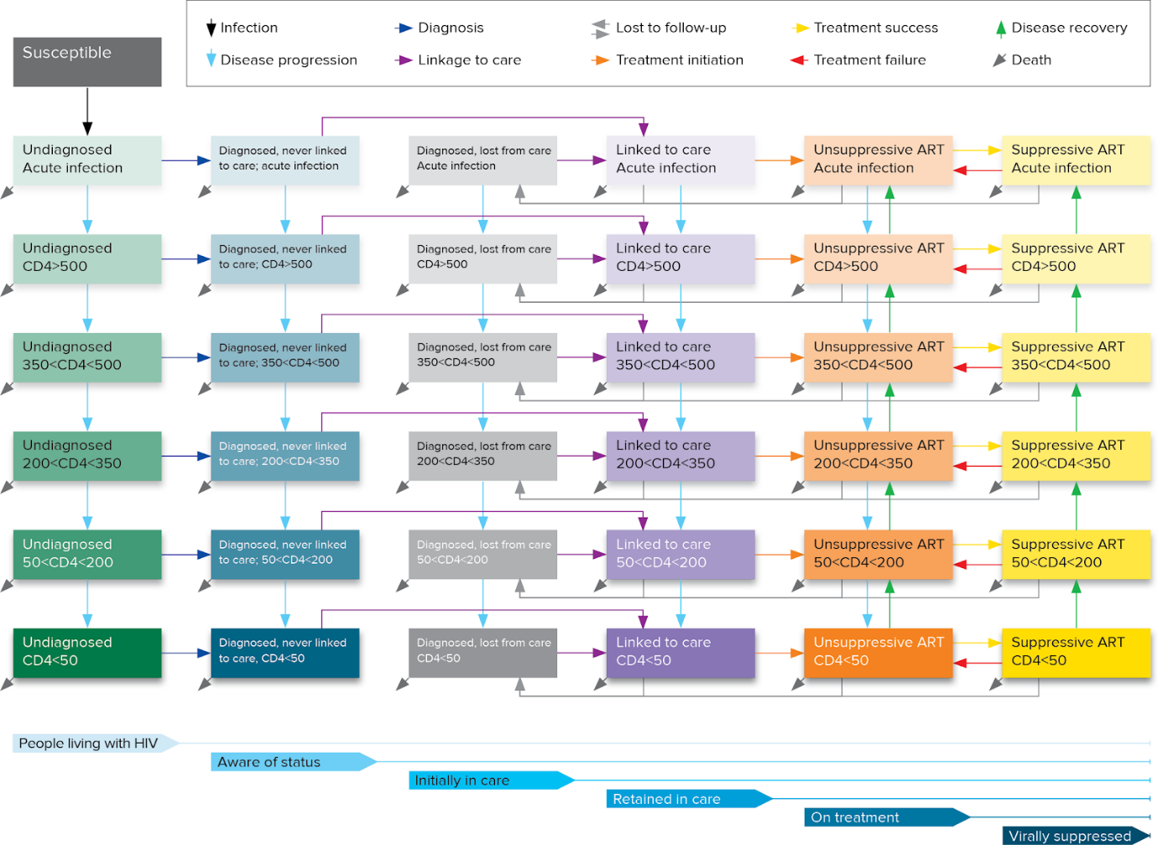
Figure A-1. Optima HIV model structure.

Methodology for model calibration
The aim of calibration is to align model outputs to available epidemiological data and official country estimates based on other models (e.g. Spectrum) as best as possible given the underlying model structure and assumptions. The main calibration parameters used for Optima HIV are ‘initial prevalence’ (the percentage of each population with HIV in the first-time step of the model, January 1, 1990), and ‘force of infection’ which represents all factors which are not modelled explicitly but which impact on the likelihood of each population becoming infected relative to other populations. Individual population prevalence estimates are calibrated to prevalence survey data relating to each population, and secondarily to match existing country estimates including new HIV infections and HIV-related deaths from Spectrum modelling to provide consistency with an agreed baseline.

Model inputs
Epidemiological, behavioural and programmatic data informing the Optima HIV model for participating countries were sourced from national records, integrated biological-behavioural surveillance (IBBS) surveys, household surveys and other studies supplemented by expert advice from stakeholder consultations. Country-specific references for key epidemic parameters are report in Appendix B.
Table A-3. Model inputs and their data sources.
Parameter | Source
Population size* | Age and gender stratified population sizes from the United Nations World Population Prospects 2024 (23). Population sizes for key populations are estimated through population size estimation studies, census (populations in prisons), or expert opinion.
HIV prevalence by population groups* | HIV prevalence data values are used as the primary point of reference during calibration. Values are taken from a combination of primary research including survey data and surveillance reports, where available, and expert opinion/assumptions where no data exists.
Other epidemiology*  - Percentage of people who die from non-HIV-related causes per year  - Prevalence of any ulcerative STIs  - Tuberculosis prevalence | Background mortality is taken from World Population Prospects, with supplementary comorbidity information from WHO reports for TB prevalence and behavioral surveys for STI prevalence.
Testing and treatment*  - Percentage of population tested for HIV in the last 12 months  - Probability of a person with CD4<200 being tested per year  - Number of people on treatment  - Proportion of exposure events covered by ARV-based pre-exposure prophylaxis  - Proportion of exposure events covered by ARV-based post-exposure prophylaxis  - Number of women on PMTCT (Option B/B+)  - Birth rate (births per woman per year)  - Percentage of HIV-positive women who breastfeed | The percentage of the population tested per year represents the likelihood that someone with an undiagnosed HIV infection will be diagnosed over the course of a year. As such inputs may be adjusted as part of calibration to match the proportion of HIV infections estimated to be diagnosed in each year, while maintaining trends in reported testing percentages. Sources include IBBS and household surveys.
Optional indicators*  - Number of HIV tests per year  - Number of HIV diagnoses per year  - Modelled estimate of new HIV infections per year  - Modelled estimate of HIV prevalence  - Modelled estimate of number of PLHIV  - Number of HIV-related deaths  - Number of people initiating ART each year  - PLHIV aware of their status (%)  - Diagnosed PLHIV in care (%)  - PLHIV in care on treatment (%)  - Pregnant women on PMTCT (%)  - People on ART with viral suppression (%) | Data entered in this section of the Optima HIV databook are not used by the model directly to generate output. These inputs allow comparison points to be entered from other reliable sources or models in order to ensure consistency. In this case Optima output were compared to Spectrum findings that have already being approved nationally through a consultative process.
Cascade*  - Average time taken to be linked to care (years) (by population groups)  - Average time taken to be linked to care for people with CD4<200 (years)  - Percentage of people in care who are lost to follow-up per year (%/year)  - Percentage of people with CD4<200 lost to follow up (%/year)  - Percentage of people lost to follow-up who are returned to care per year (%/year)  - Viral load monitoring (number/year)  - Proportion of those with identified viral load failure who are provided with effective adherence support or a successful new regimen (%/year)  - Treatment failure rate | Cascade parameters informed by programmatic data and expert opinion.
Sexual behavior*  - Average number of acts with regular partners per person per year  - Average number of acts with casual partners per person per year  - Average number of acts with transactional partners per person per year  - % age of people who used a condom at last act with regular partners  - Percentage of people who used a condom at last act with casual partners  - Percentage of people who used a condom at last act with transactional partners  - Percentage of males who have been traditionally circumcised  - Number of voluntary medical male circumcisions | Sources for sexual behavior include IBBS and household surveys. Number of voluntary medical male circumcisions informed by programmatic data.
Injecting behaviors*  - Average number of injections per person per year  - Percentage of people who receptively shared a needle/syringe at last injection  - Number of people who inject drugs who are on opioid substitution therapy | Sources for injecting behavior include IBBS and other survey data.
Partnerships and transitions*  - Interactions between regular partners  - Interactions between casual partners  - Interactions between transactional partners  - Interactions between people who inject drugs  - Birth  - Aging  - Risk-related population transitions (average number of years before movement | Informed by population definitions and behavioral survey data. Aging rates based on demographics in United Nations World Population Prospects 2024.  Risk transitions account for temporal behaviours and risks as well as overlap between population groups.
Migration*  - Percentage of people who emigrate per year  - Number of people who immigrate into population per year  - HIV prevalence of immigrants into population per year  - Proportion of people living with HIV who immigrate who are diagnosed prior to arrival | Optionally included depending on significance to epidemic and available data. Sources for numbers of emigrants and immigrations based on United Nations World Population Prospects 2024, International Organization for Migration Displacement Tracking Matrix or national reports. Estimates for HIV prevalence and diagnosis among migrants informed by programmatic or survey data.
Constants  - Interaction-related transmissibility (% per act)  - Relative disease-related transmissibility  - Disease progression (average years to move)  - Treatment recovery due to suppressive ART (average years to move)  - CD4 change due to non-suppressive ART (%/year)  - Death rate (% mortality per year)  - Changes in transmissibility (%)  - Disutility weights | Source for constant values used for Optima HIV are outlined in the Optima HIV User Guide Volume VI Parameter Data Sources.
*Values can be defined annually for each year.
ART, antiretroviral treatment; IBBS, integrated biological behavioural surveillance surveys; PLHIV, people living with HIV; PMTCT, prevention of mother-to-child transmission (vertical transmission); STI, sexually transmitted infection.

Program data and reconciliation process
For each modelled HIV program (defined as a specific intervention or service modality), the following parameters are defined:
- Total annual spending – total spending to implement a service or intervention over one year either reported directly (top-down estimate) or calculated from unit costs and program coverage (bottom-up estimate);
- Coverage - Number of people reached by the intervention (e.g. number of people treated or tested) over one year;
- Unit cost - cost per person reached per year (e.g. cost per person per year on treatment, cost per person tested per year);
- Saturation - maximum proportion of the target population that could feasibly be reached by the intervention given geographical, social or other constraints;
- Impact of intervention – defined based on behavioural parameters influenced (e.g. HIV testing rate per year and positive yield, casual condom use) and the expected outcomes in (a) absence of the program, and (b) for each person reached by the program.
Spending estimates should include all scalable costs to deliver a service including commodities, time and salary of staff (e.g. health care workers, peer educators, laboratory personnel), cost of supply logistics (e.g. outreach transport costs, online communication, appointment reminders), and demand generation. Indirect and fixed costs such as management, overhead costs, and administrative costs are generally excluded, but if these cannot be excluded, then a consistent approach should be used for all interventions.
Program impacts are informed by program data and definitions, international literature, and historical data. For example:
- Historical values prior to program implementation may provide a baseline for program impact, although in many cases the baseline if the program was removed may be higher than historical values due to changes in social norms.
- The baseline may be informed by demand and access to products or services outside of public HIV services, such as HIV testing through private clinics (out-of-pocket), private purchasing of condoms or needle/syringes, access to HIV testing outside of the country prior to or during migration, and demand for condoms irrespective of HIV messaging and distribution (such as for family planning).
- For those reached by a program for HIV testing, the impact is influenced by both the average number of tests per person tested and the yield of testing (% positive) relative to undiagnosed prevalence in the population. A highly targeted program may have a higher yield relative to other modalities, and thus higher program impact. A testing program with regular repeat testing may have a reduced positive yield and lower program impact.
- Longitudinal studies, program evaluations or meta-analyses may provide data on anticipated outcomes relative to baseline values (relative risk).
The reconciliation process aligns program impact across all programs that influence a parameter (e.g. multiple programs might result in HIV testing for a key population) with the latest behavioural survey data, given the most recently reported program coverage.

Key epidemic data inputs
Table B-1. Most recent estimates for population size and HIV prevalence for key populations and total population.
Population | Most recent population size estimate (year) | Notes and source | Most recent HIV prevalence estimate (year) | Notes and source
Female sex workers | 21,980 (2024)  0.45% F15-49 | GAM 2024 (provided by country) | 1.5% (2023) | Sentinel surveillance 2023 via KP Atlas (2025)
Clients of female sex workers | 219,800 (2024)  4.5% M15-49 | Assumed 10x population of FSW | N/A | N/A
Men who have sex with men | 71,000 (2024)  1.45% M15-49 | GAM 2024 | 8.8% (2024) | Biobehavioural study (BBS) 2024
Male people who inject drugs | 61,642 (2025)  1.2% M15-49 | BBS 2024 | 6.4% (2024) | BBS 2024
Female people who inject drugs | 12,358 (2025)  0.3% F15-49 | BBS 2024 | 11.6% (2024) | BBS 2024
Other men at high risk | 39,183 (2024)  0.8% M15-49 | KSСDID data | 3.8% (2024) | Programme data 2024 reflecting men in closed settings via KP Atlas (2025)
Total population size | 20,592,571 (2024) | WPP 2024 | N/A | HIV prevalence among non-key populations calibrated based on Spectrum estimates for overall number of people living with HIV, new HIV infections and HIV-related deaths.
BBS, biobehavioral survey; FSW, female sex workers; GAM, Global AIDS Monitoring.

HIV program costing and impacts
Table C-1. HIV program unit costs in 2024 and maximum potential coverage (saturation).
HIV program | Unit cost (US$) | Current coverage | Maximum potential coverage | Notes
HIV treatment | $760.52 | 31614 (87%)¹ | 100% | Includes ART, viral load monitoring, adherence and retention support.
Prevention of mother-to-child transmission | $719.37 | 530 (68%)² | 100%
Condom program | $7.78 | 96600 (1%) | 10% | Condom distribution among adults outside of key populations (M15-49 and F15-49) and other men at high risk.
Facility-based testing | $1.90 | 4,149,928 (29%) | 50% | Captures testing of people outside of key populations, including clients of FSW
Prevention and testing services for female sex workers | $26.45 | 18423 (84%) | 85% | Includes condom distribution and HIV testing. Also reaches some females who inject drugs.
Prevention and testing services for men who have sex with men | $76.07 | 17728 (25%) | 50% | Includes condom distribution and HIV testing. Maximum potential coverage limited due to stigma and barriers to identifying as gay, bisexual or other men who have sex with men.
Prevention and testing services for people who inject drugs | $27.87 | 52624 (66%) | 85% | Includes needle and syringe program, condom distribution and HIV testing
Opioid substitution treatment | $1,395.76 | 380 (0.5%) | 1% | Maximum based on the proportion of PWID using heroin. Maximum coverage limited by policy constraints.
Pre-exposure prophylaxis | $46.65 | 3143 (4%) MSM  2722 (12%) FSW  4841 (6%) PWID | 15% MSM³  20% FSW³  15% PWID³ | Average annual cost per person based on oral PrEP. Assume those reached by PrEP have a relative risk of 2 of acquiring HIV compared to those not on PrEP. Assumes average continuation of 4 months. PrEP continuation and effectiveness modelled on oral PrEP.
1, Percentage of diagnosed people living with HIV; 2, percentage among modelled number of pregnant women living with HIV; 3, Proportion of population. Modelled parameter converted to percentage of risk covered taking into account the population susceptible to HIV, relative risk of those on PrEP compared to those not on PrEP (assumed 2) and average continuation.
ART, antiretroviral treatment; FSW, female sex workers; MSM, men who have sex with men; PrEP, pre-exposure prophylaxis; PWID, people who inject drugs.
Source: Unit costs derived through top-down estimation with total spending and coverage provided by the provided by KRCDIZ.

Table C-2. Data inputs of impact of programs.
HIV program | Parameter | Population interactions or population | In absence of any programs | For each individual reached by this program
Condoms | Condom use for casual acts | Clients, FSW | 74% | 90%
Condoms | Condom use for casual acts | Clients, Female PWID | 83% | 90%
Condoms | Condom use for casual acts | Clients, Females 15-49 | 80% | 90%
Condoms | Condom use for casual acts | MSM, Females 15-49 | 73% | 90%
Condoms | Condom use for casual acts | Male PWID, Females 15-49 | 60% | 85%
Condoms | Condom use for casual acts | Males 15-49, FSW | 73% | 90%
Condoms | Condom use for casual acts | Males 15-49, Female PWID | 71% | 90%
Condoms | Condom use for casual acts | Males 15-49, Females 15-49 | 80% | 90%
Condoms | Condom use for casual acts | Males 50+, Females 15-49 | 49% | 60%
Condoms | Condom use for casual acts | Other high-risk, Other high-risk | 4% | 95%
FSW programs | Condom use for casual acts | Clients, FSW | 74% | 90%
FSW programs | Condom use for casual acts | Males 15-49, FSW | 73% | 90%
MSM programs | Condom use for casual acts | MSM, MSM | 61% | 95%
PWID programs + NSP | Condom use for casual acts | Male PWID, Female PWID | 70% | 90%
PWID programs + NSP | Condom use for casual acts | Male PWID, Females 15-49 | 60% | 90%
PWID programs + NSP | Condom use for casual acts | Males 15-49, Female PWID | 71% | 90%
FSW programs | Condom use for commercial acts | Clients, FSW | 79% | 95%
FSW programs | Condom use for commercial acts | Clients, Female PWID | 79% | 95%
FSW programs | Condom use for commercial acts | Male PWID, FSW | 84% | 95%
FSW programs | Condom use for commercial acts | Male PWID, Female PWID | 83% | 95%
MSM programs | Condom use for commercial acts | MSM, MSM | 3% | 14%
MSM programs | Condom use for regular acts | MSM, MSM | 31% | 60%
HTS | HIV testing rate (average tests per year) | Clients | 0.0 | 1.0
HTS | HIV testing rate (average tests per year) | Males 0-14 | 0.0 | 0.1
HTS | HIV testing rate (average tests per year) | Females 0-14 | 0.0 | 0.1
HTS | HIV testing rate (average tests per year) | Males 15-49 | 0.0 | 1.0
HTS | HIV testing rate (average tests per year) | Females 15-49 | 0.0 | 1.0
HTS | HIV testing rate (average tests per year) | Males 50+ | 0.0 | 1.0
HTS | HIV testing rate (average tests per year) | Females 50+ | 0.0 | 1.0
PrEP FSW | HIV testing rate (average tests per year) | FSW | 0.0 | 1.0
PrEP MSM | HIV testing rate (average tests per year) | MSM | 12% | 1.33
PrEP PWID | HIV testing rate (average tests per year) | Male PWID | 0.0 | 1.0
PrEP PWID | HIV testing rate (average tests per year) | Female PWID | 0.0 | 1.0
FSW programs | HIV testing rate (average tests per year) | FSW | 0.0 | 1.72
FSW programs | HIV testing rate (average tests per year) | Female PWID | 0.0 | 0.30
MSM programs | HIV testing rate (average tests per year) | MSM | 0.12 | 2.95
PWID programs + NSP | HIV testing rate (average tests per year) | Male PWID | 0.0 | 1.27
PWID programs + NSP | HIV testing rate (average tests per year) | Female PWID | 0.0 | 1.25
FSW programs | Probability of needle sharing (per injection) | Female PWID | 19% | 10%
PWID programs + NSP | Probability of needle sharing (per injection) | Male PWID | 19% | 2%
PWID programs + NSP | Probability of needle sharing (per injection) | Female PWID | 19% | 2%
PrEP FSW | Proportion of exposure events covered by ARV-based pre-exposure prophylaxis | FSW | 0% | 100%
PrEP MSM | Proportion of exposure events covered by ARV-based pre-exposure prophylaxis | MSM | 0% | 100%
PrEP PWID | Proportion of exposure events covered by ARV-based pre-exposure prophylaxis | Male PWID | 0% | 100%
PrEP PWID | Proportion of exposure events covered by ARV-based pre-exposure prophylaxis | Female PWID | 0% | 100%
OST | Number of PWID on OST | Total | 0 | -
PMTCT | Number of people on PMTCT | Total | 0 | -
ART | Number of people on treatment | Total | 0 | -
- The number of people modeled as receiving ART is equal to the coverage of the respective programs.
Condoms, condom distribution and promotion among adults outside of key populations and other men at high risk; FSW, female sex worker; HTS, Facility-based HIV testing services for people outside of key populations; OST, opioid substitution treatment; PWID, people who inject drugs; PMTCT, prevention of mother-to-child (vertical) transmission; PrEP, pre-exposure prophylaxis.

Figure C-1. Cost functions for modelled HIV programs.
Figures show relationship between total spending and number covered among targeting population of each program, with points representing each historical year for which we have both total spending and coverage data. The curve captures the modelled estimate of how coverage changes with increased spending. A linear relationship between cost and coverage means that unit cost remains constant with changing coverage. In non-linear relationships, the effective unit cost increases as coverage approaches the maximum achievable coverage.
The curve captures the modelled estimate of how coverage changes with increased spending, with increases resources typically needed to reach additional people as the program gets close to maximum coverage.
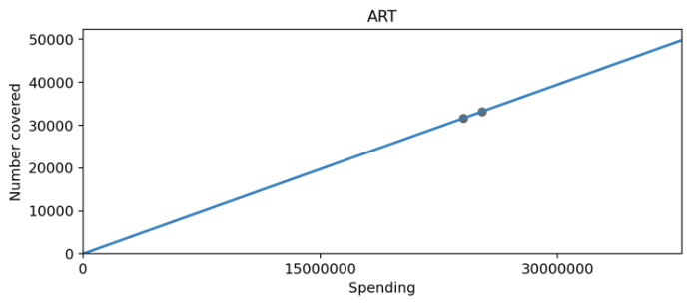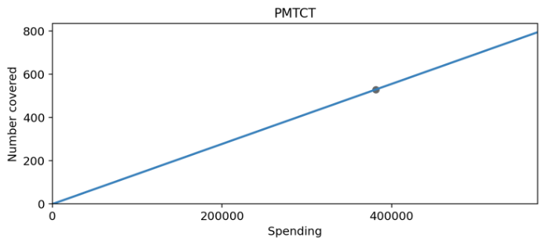
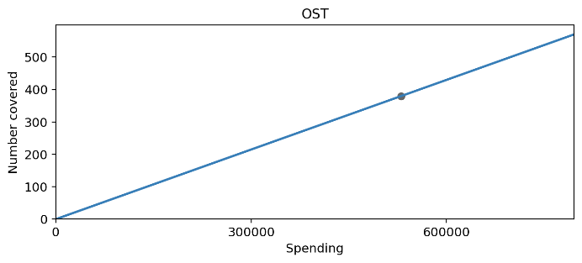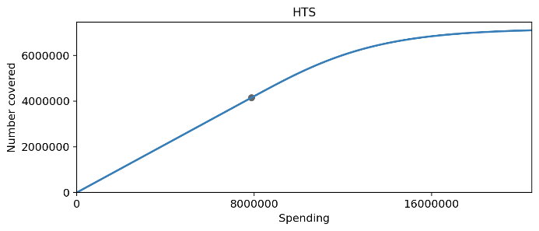
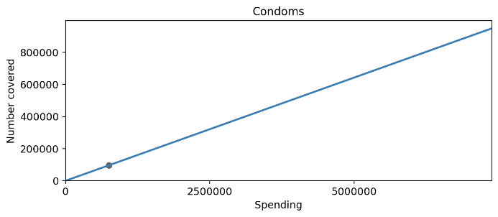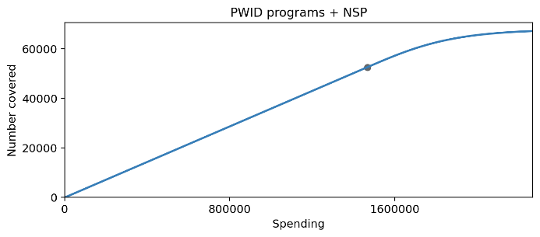
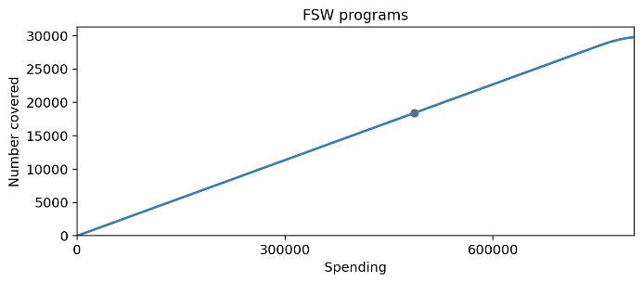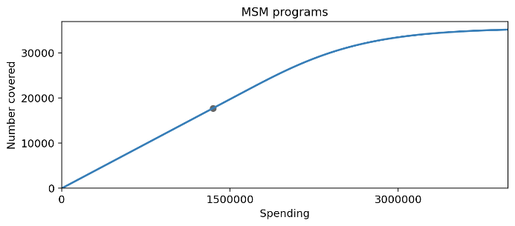
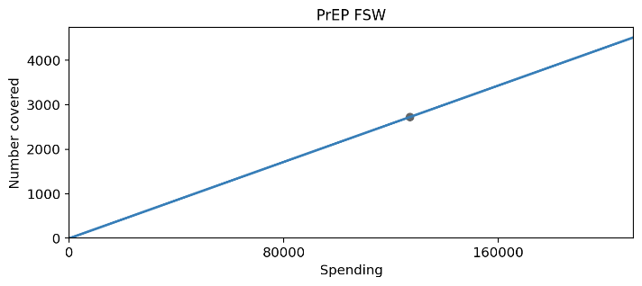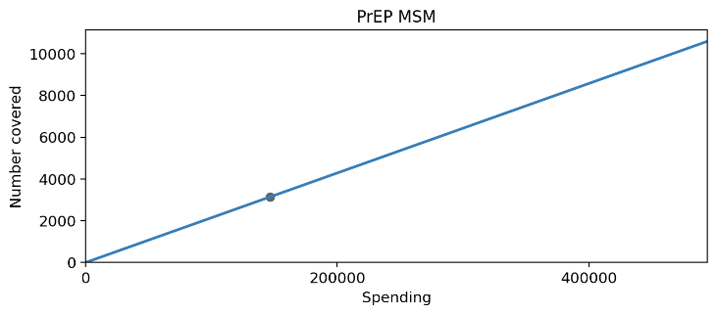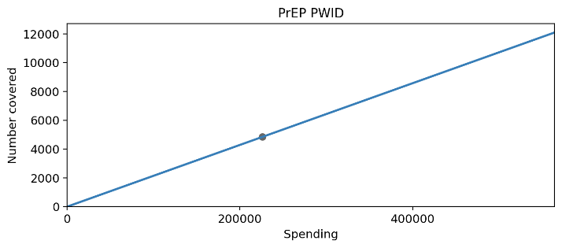

Model calibration
Calibration outputs. Dots represent official country estimates based on World Population Prospects, Spectrum model, surveillance surveys, program data and UNAIDS estimates.
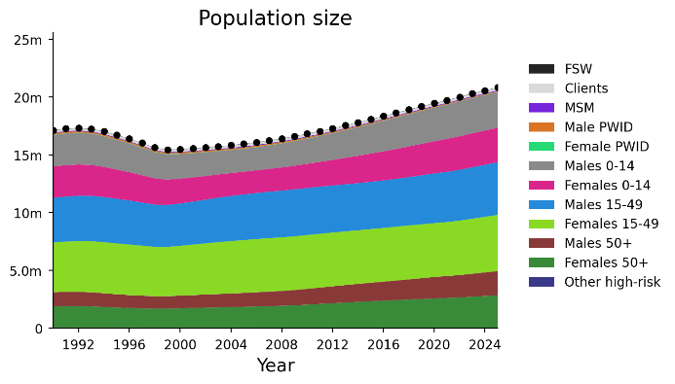 |  | 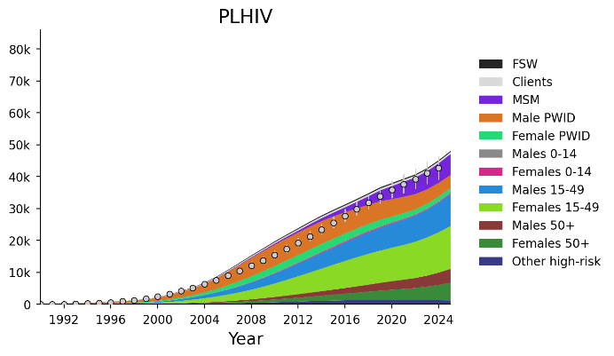
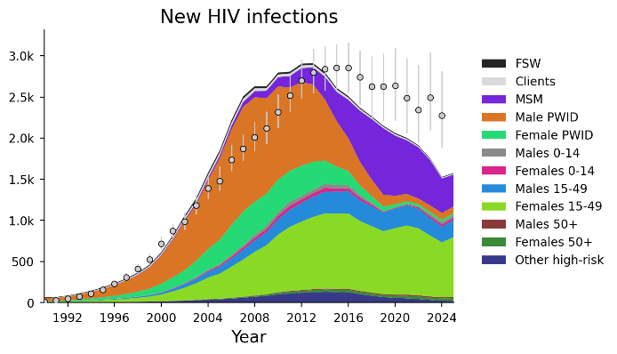 |  | 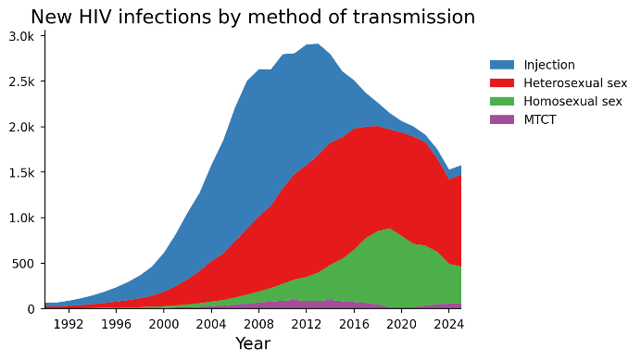
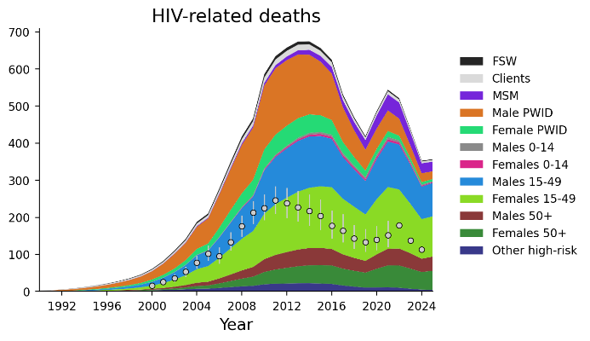  Note. Comparative data in circle markers represents number of deaths HIV reported in national Electronic HIV Case-based Surveillance System. Optima modelled numbers expected to be higher because also captures deaths among undiagnosed people living with HIV. |  | 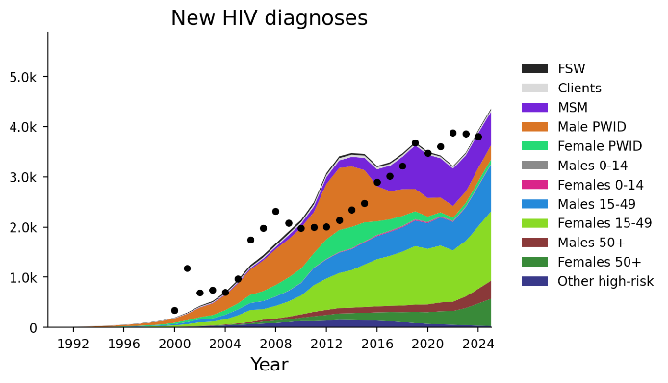
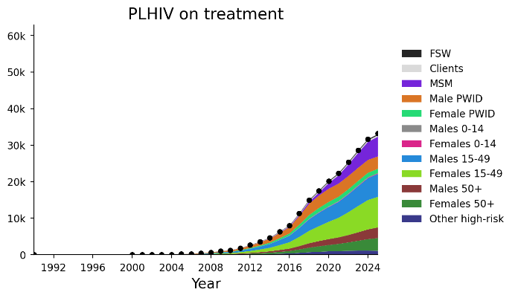 |  | 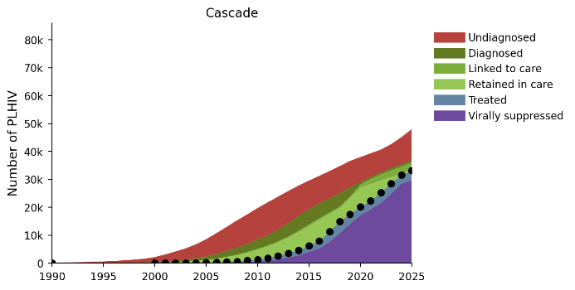
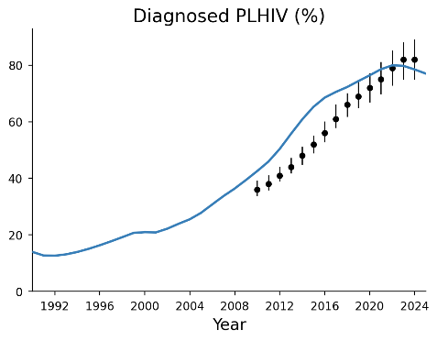 | 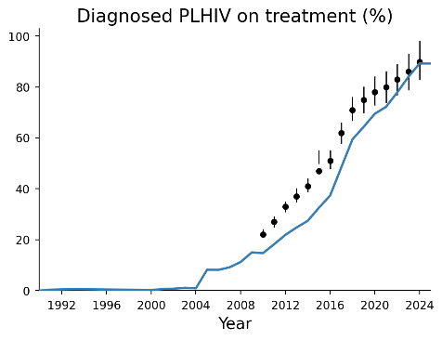 |  | 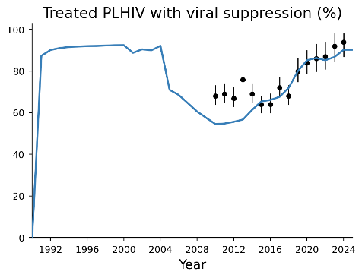
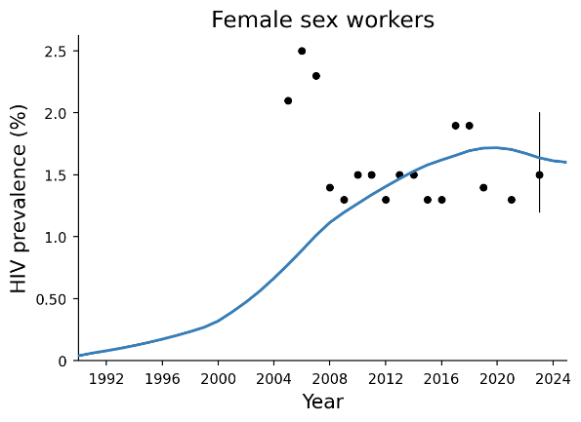 |  | 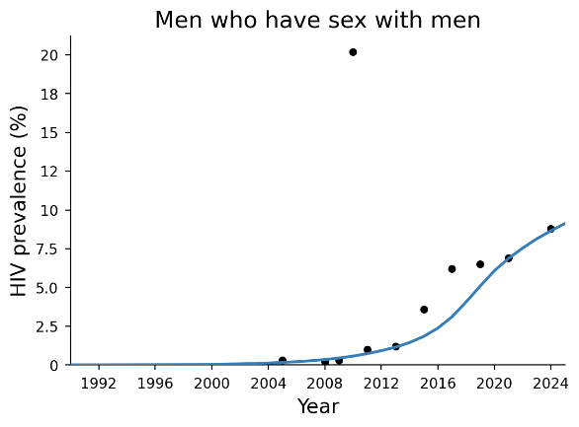
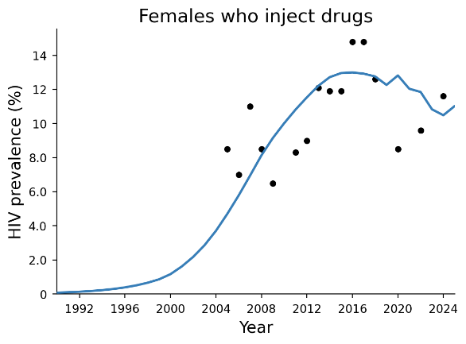 |  | 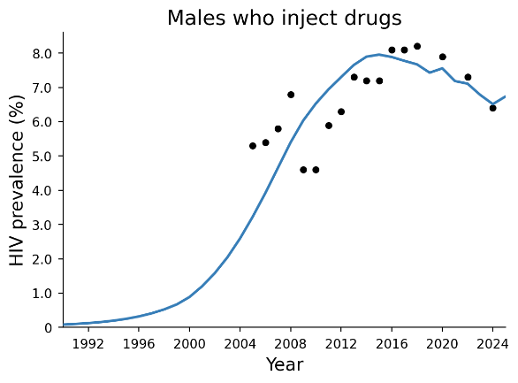
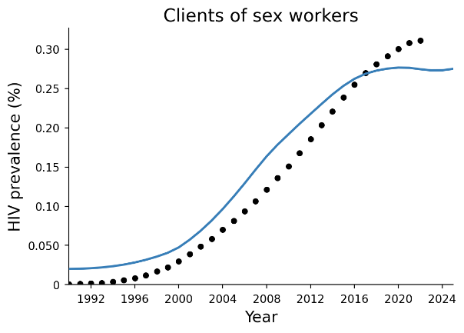 |  | 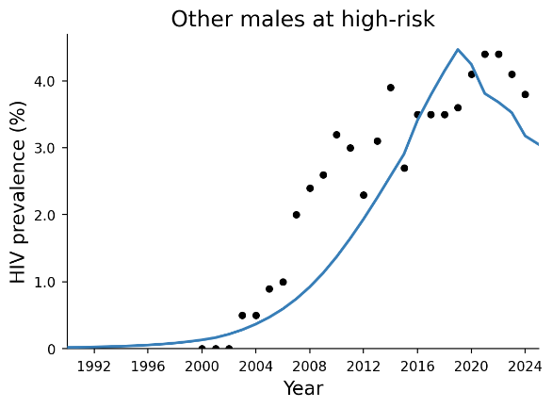
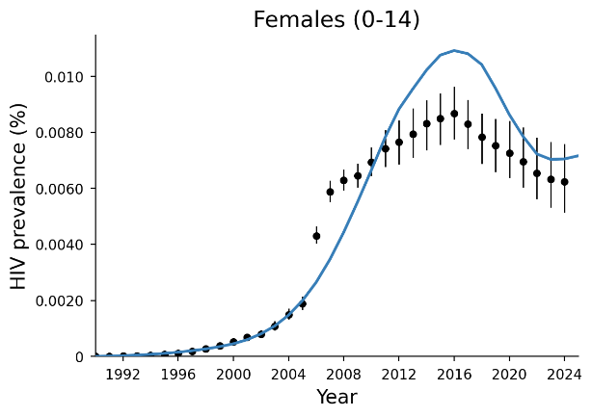 |  | 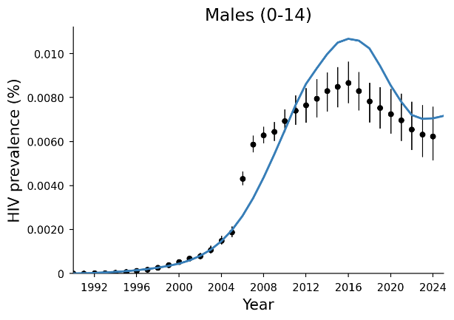
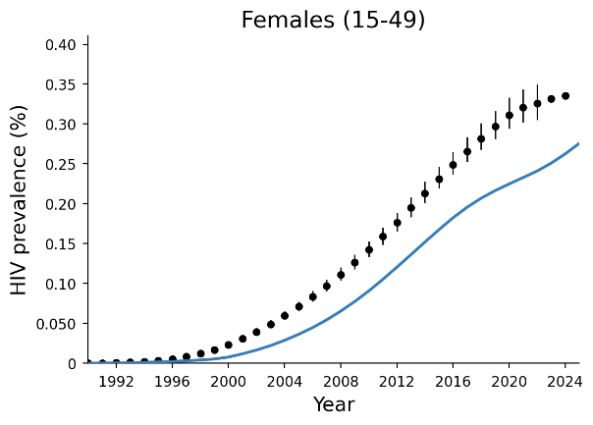 |  | 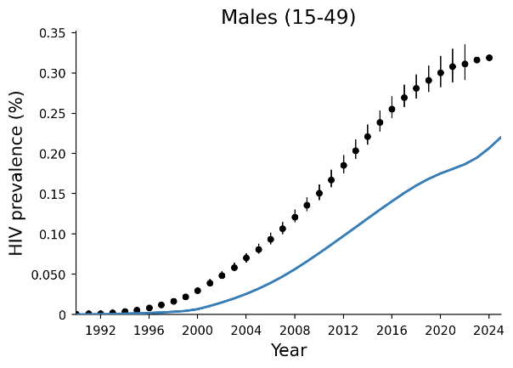
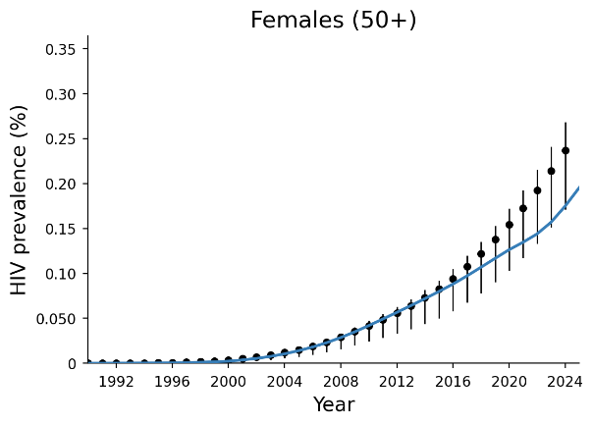 |  | 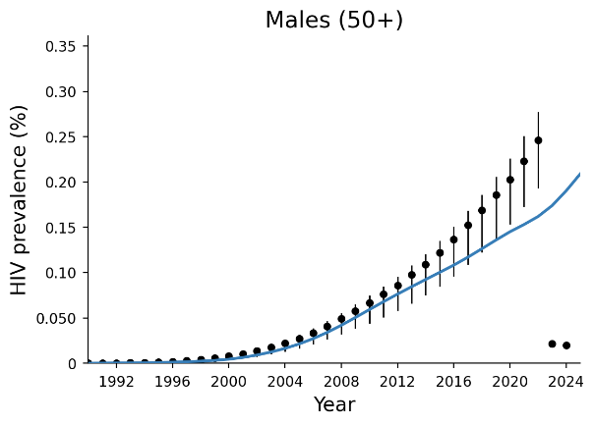
Figure D-1. Sex disaggregation of new cases based on national surveillance reporting compared to Optima modelled estimates for new diagnoses and new HIV infections, year 2024.

Detailed results
Table E-1. Annual HIV budget (US$) allocations among targeted HIV programs at varying budgets for 2026 to 2030.
Program | 2025 spending  (Counterfactual) | 50% spending optimized | 75% spending optimized | 100% spending optimized | 125% spending optimized | 150% spending optimized | 200% spending optimized | Optimized 2025 spending + $6.7M p.a. to meet treatment demand*
ART | $25,229,984 | $18,613,273 | $22,557,093 | $28,772,415 | $31,658,739 | $32,899,756 | $33,167,869 | $30,717,637
HTS | $7,876,666 | $0 | $3,521,102 | $3,938,333 | $9,636,597 | $15,834,656 | $25,801,742 | $7,410,363
PWID programs | $1,466,809 | $0 | $655,707 | $1,652,106 | $1,886,575 | $2,231,496 | $2,882,912 | $1,948,197
MSM programs | $1,348,601 | $0 | $602,864 | $1,908,200 | $2,728,725 | $3,614,834 | $5,632,488 | $2,836,059
Condoms | $751,362 | $0 | $335,881 | $375,681 | $375,685 | $375,681 | $6,153,126 | $375,682
OST | $530,389 | $391,291 | $474,199 | $530,389 | $530,395 | $530,389 | $697,261 | $530,390
FSW programs | $487,206 | $0 | $217,795 | $243,603 | $243,606 | $785,319 | $917,671 | $243,604
PMTCT | $381,267 | $281,278 | $340,875 | $461,625 | $461,628 | $461,627 | $461,628 | $461,628
PrEP PWID | $225,817 | $0 | $100,947 | $112,909 | $112,910 | $539,851 | $554,785 | $212,449
PrEP MSM | $146,610 | $0 | $65,539 | $512,937 | $516,258 | $520,431 | $624,329 | $517,747
PrEP FSW | $126,973 | $0 | $56,761 | $63,487 | $63,487 | $63,487 | $249,557 | $63,487
Total | $38,571,684 | $19,285,842 | $28,928,763 | $38,571,684 | $48,214,605 | $57,857,526 | $77,143,367 | $46,079,617
* An additional $6.7 million was calculated based on the necessary resources to maintain status quo treatment coverage (ART & PMTCT) prior to optimization.
ART, antiretroviral treatment; Condoms, condom distribution and promotion among adults outside of key populations and other men at high risk; FSW, female sex worker; HTS, HIV testing services (facility-based); HIVST, HIV self-testing; MSM, men who have sex with men; OST, opioid substitution treatment; PMTCT, prevention of mother-to-child transmission; PrEP, pre-exposure prophylaxis (oral); PWID, people who use inject drugs.
Table E-2. Change in HIV spending allocation at varying HIV budget levels relative to latest reported spending (counterfactual).
Program | 50% spending optimized | 75% spending optimized | 100% spending optimized | 125% spending optimized | 150% spending optimized | 200% spending optimized | Optimized 2025 spending + $6.7M p.a. to meet treatment demand*
ART | -$6,616,711  (-26%) | -$2,672,891  (-11%) | $3,542,431  (14%) | $6,428,755  (25%) | $7,669,772  (30%) | $7,937,885  (31%) | $5,487,653  (22%)
HTS | -$7,876,666  (-100%) | -$4,355,564  (-55%) | -$3,938,333  (-50%) | $1,759,931  (22%) | $7,957,990  (101%) | $17,925,076  (228%) | -$466,303  (-6%)
PWID programs | -$1,466,809  (-100%) | -$811,102  (-55%) | $185,297  (13%) | $419,766  (29%) | $764,687  (52%) | $1,416,103  (97%) | $481,388  (33%)
MSM programs | -$1,348,601  (-100%) | -$745,737  (-55%) | $559,599  (41%) | $1,380,124  (102%) | $2,266,233  (168%) | $4,283,887  (318%) | $1,487,458  (110%)
Condoms | -$751,362  (-100%) | -$415,481  (-55%) | -$375,681  (-50%) | -$375,677  (-50%) | -$375,681  (-50%) | $5,401,764  (719%) | -$375,680  (-50%)
OST | -$139,098  (-26%) | -$56,190  (-11%) | $0  (0%) | $6  (0%) | $0  (0%) | $166,872  (31%) | $1  (0%)
FSW programs | -$487,206  (-100%) | -$269,411  (-55%) | -$243,603  (-50%) | -$243,600  (-50%) | $298,113  (61%) | $430,465  (88%) | -$243,602  (-50%)
PMTCT | -$99,989  (-26%) | -$40,392  (-11%) | $80,358  (21%) | $80,361  (21%) | $80,360  (21%) | $80,361  (21%) | $80,361  (21%)
PrEP PWID | -$225,817  (-100%) | -$124,870  (-55%) | -$112,909  (-50%) | -$112,907  (-50%) | $314,034  (139%) | $328,968  (146%) | -$13,368  (-6%)
PrEP MSM | -$146,610  (-100%) | -$81,071  (-55%) | $366,327  (250%) | $369,648  (252%) | $373,821  (255%) | $477,719  (326%) | $371,137  (253%)
PrEP FSW | -$126,973  (-100%) | -$70,212  (-55%) | -$63,487  (-50%) | -$63,486  (-50%) | -$63,487  (-50%) | $122,584  (97%) | -$63,486  (-50%)
* An additional $6.7 million was calculated based on the necessary resources to maintain status quo treatment coverage (ART & PMTCT) prior to optimization.
ART, antiretroviral treatment; Condoms, condom distribution and promotion among adults outside of key populations and other men at high risk; FSW, female sex worker; HTS, HIV testing services (facility-based); HIVST, HIV self-testing; MSM, men who have sex with men; OST, opioid substitution treatment; PMTCT, prevention of mother-to-child transmission; PrEP, pre-exposure prophylaxis (oral); PWID, people who use inject drugs.

Table E-3. Cumulative new HIV infections and HIV-related deaths between 2026-2030 under different scenarios with fixed treatment coverage, and differences in impacts compared to the status quo scenario.
 | Cumulative number,  2026-2030 |  | Difference from status quo
 | New HIV infections | HIV-related deaths | New HIV infections | HIV-related deaths
Status quo (2025 spending +$6.7M p.a. to meet treatment demand*) | 8,566 | 2,090 | 0 (0%) | 0 (0%)
Optimized 2025 spending + $6.7 p.a. to meet treatment demand* | 7,551 | 2,068 | -1,014 (-12%) | -22 (-1%)
HIV prevention and testing removed from 2026** | 12,841 | 2,149 | 4,276 (-50%) | 59 (-3%)
* An additional $6.7 million was calculated based on the necessary resources to maintain status quo treatment coverage (ART & PMTCT) prior to optimization.
** Considers the removal of all prevention and key population-focused testing services from 2026, with treatment (ART, PMTCT, OST) and facility-based testing services maintained (fixed percentage of diagnosed people living with HIV).
Table E-4. Cumulative new HIV infections and HIV-related deaths between 2026-2030 under different scenarios, and differences in impacts compared to the counterfactual scenario of fixed spending on HIV programs.
 | Cumulative number,  2026-2030 |  | Difference from counterfactual
 | New HIV infections | HIV-related deaths | New HIV infections | HIV-related deaths
Counterfactual (100% spending) | 12,131 | 3,216 | 0 (0%) | 0 (0%)
50% spending optimized* | 23,108 | 4,571 | 10978 (90%) | 1355 (42%)
75% spending optimized* | 16,484 | 3,789 | 4353 (36%) | 574 (18%)
100% spending optimized | 8,448 | 2,224 | -3683 (-30%) | -991 (-31%)
125% spending optimized | 7,316 | 1,995 | -4814 (-40%) | -1220 (-38%)
150% spending optimized | 6,764 | 1,889 | -5367 (-44%) | -1326 (-41%)
200% spending optimized | 6,647 | 1,868 | -5484 (-45%) | -1348 (-42%)
* All budget levels were constrained to not reduce spending for treatment interventions. The 50% spending optimized scenarios applied no constraints to other reallocation of funds and is thus not directly comparable to other scenarios where spending was constrained to not be reduced by more than 50%. At the 50% and 75% budget levels the total budget was insufficient to maintain those constraints so all constrained interventions were scaled proportionally.


Australia
85 Commercial Road
Melbourne, Victoria, 3004
t + 61 3 9282 2111
e info@burnet.edu.au

Overseas
Burnet has offices or representatives in Australia, Papua New Guinea and Myanmar, and also contributes to research and public health programs in many other countries across Asia, the Pacific, Africa, Europe,
and North America.

 burnet.edu.au
 burnet.edu.au/support-us
 burnetinstitute
 BurnetInstitute
 Burnet Institute

